## WebAPI

Interview questions:

<https://www.youtube.com/watch?v=fT_S2_2hTOo>

2. For which purpose you created WebAPI

3. who will decide API schemas

8. how can you will call webAPI

9. how can you will implement security to the webapi

How can implement dependency injection in webapi

How can you implement routing?

What is cors?

What is nugetjson? You implemented cors to this?

How can provide security to webapi? **Authorization** tag.

What is Razor?

How can you will restrict a method to expose to the public?

**[NonAction]**  
public void DoInternalStuff()  
{  
    Response.Write("We are doing internal stuff here!");  
    Response.End();  
}

## Node Js

1. What is callback function

2. What are the benefits of node

3. How you use node in react js

4. What are the advantages of react

5. compare with angular how it is good

17. React hook

18. What is HOC

5. Diff. b/w webforms and react js

7. what is arrow function?

React js life cycle methods

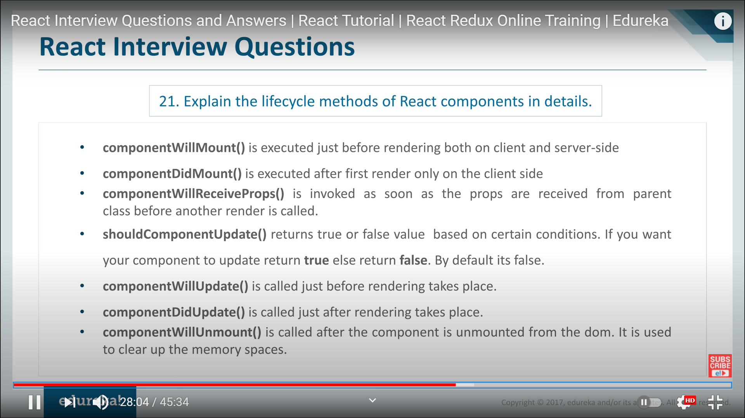

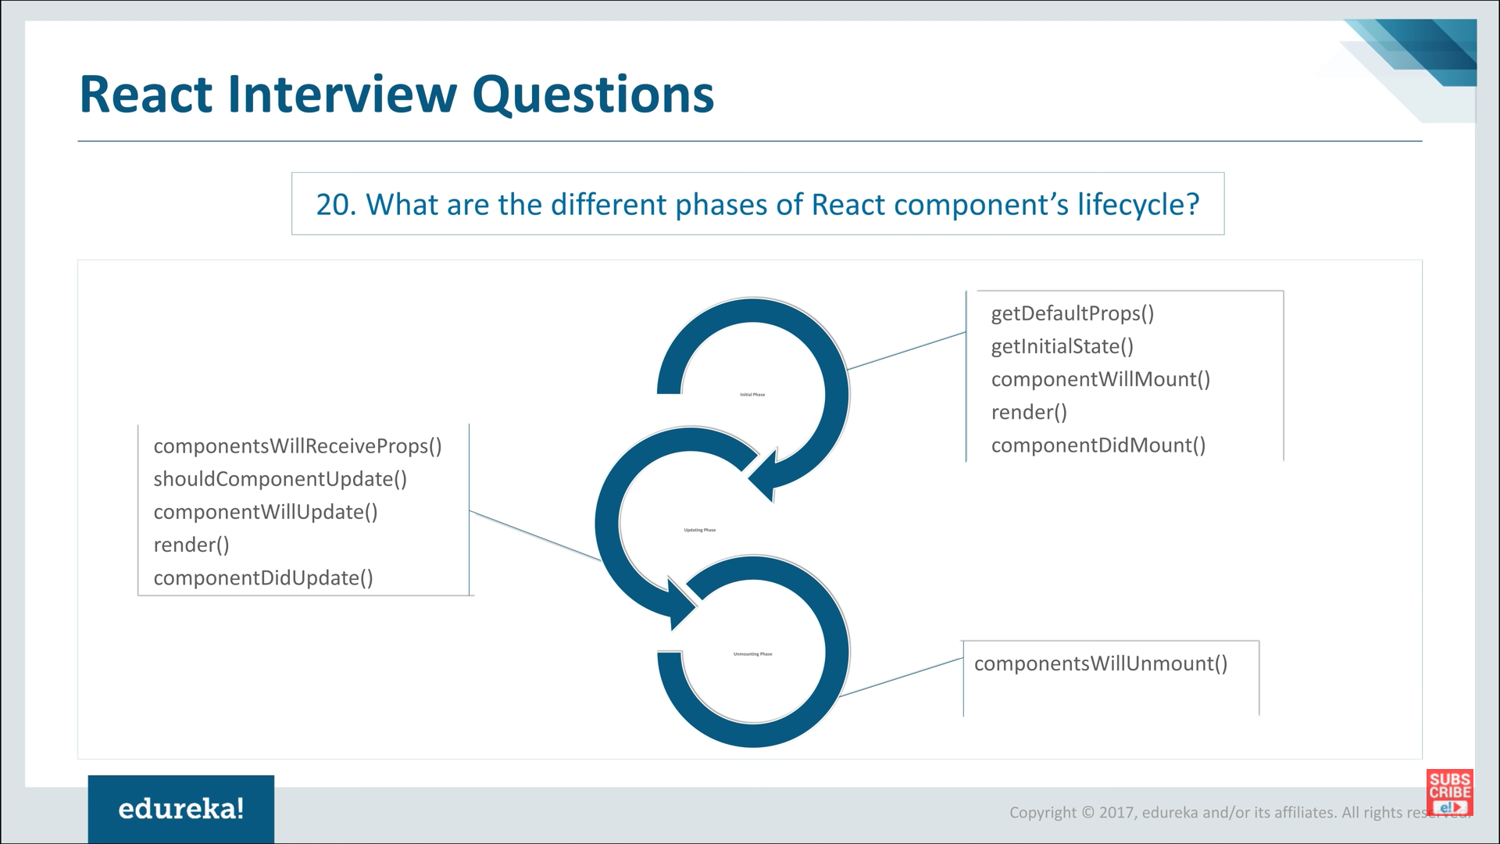

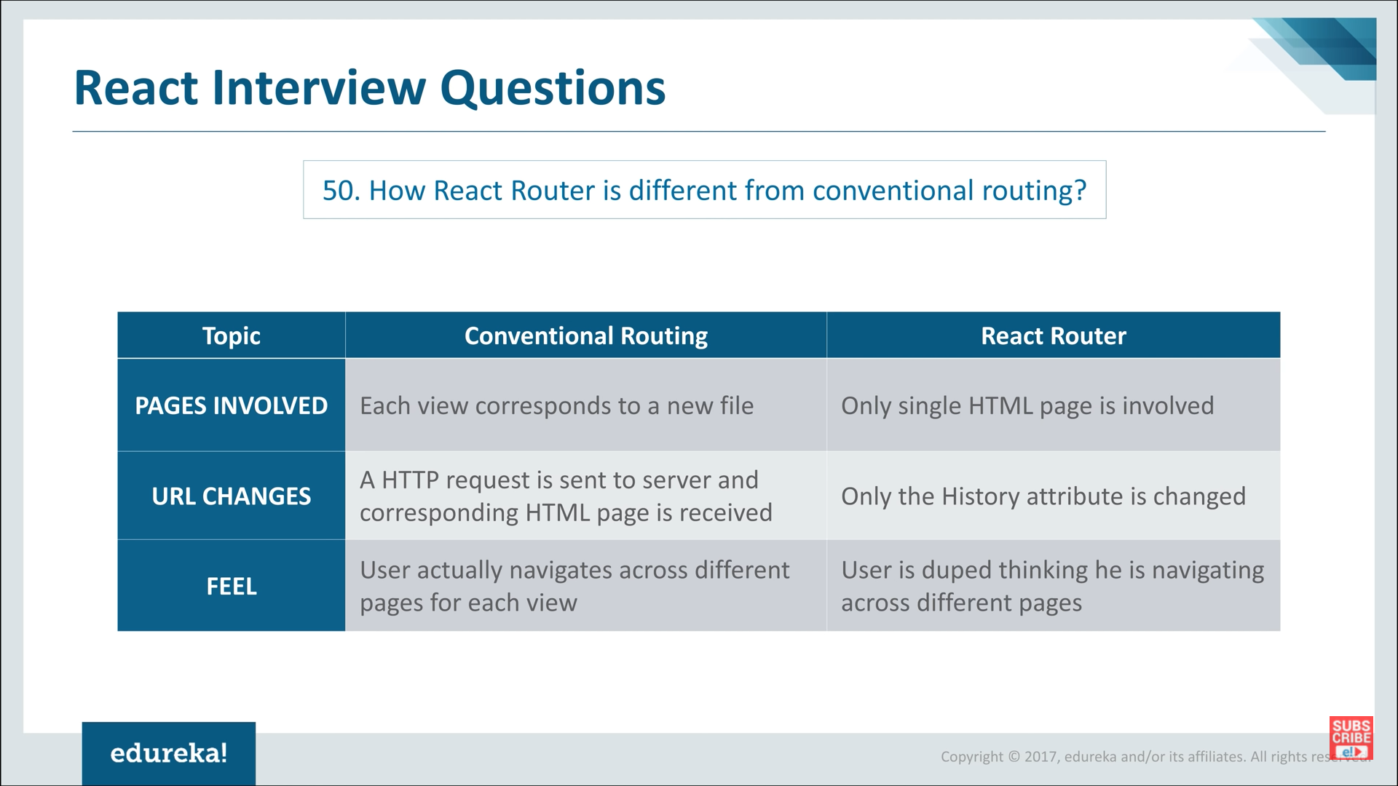

6. Diff b/w React & angular js?

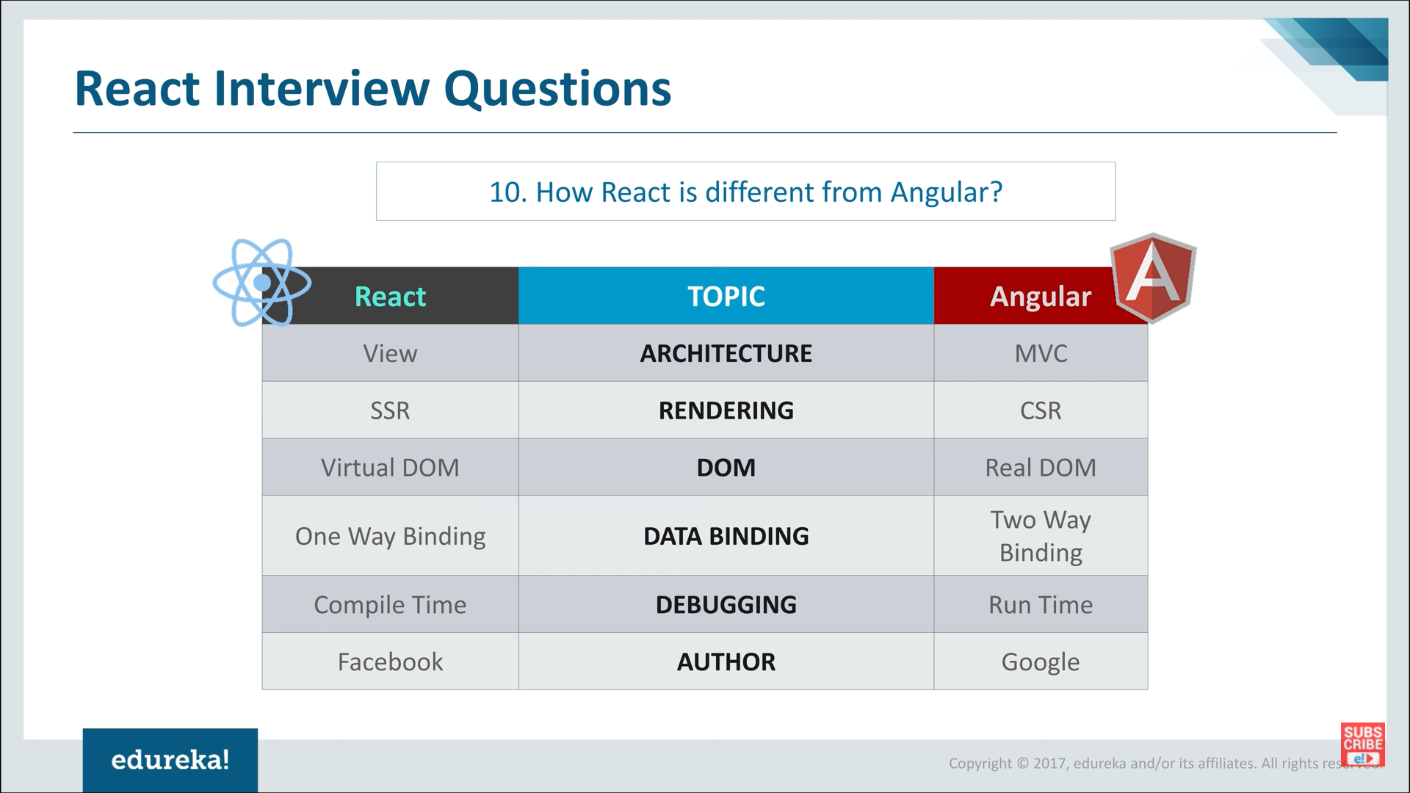

## .Net

8. What is the design methodology you are following

10. write a program to display the order of the letters "daba345cz12ZB"

Diff be

List<int>

int[]

-------------

lock vs Monitor

lock and monitor both will do same operations.

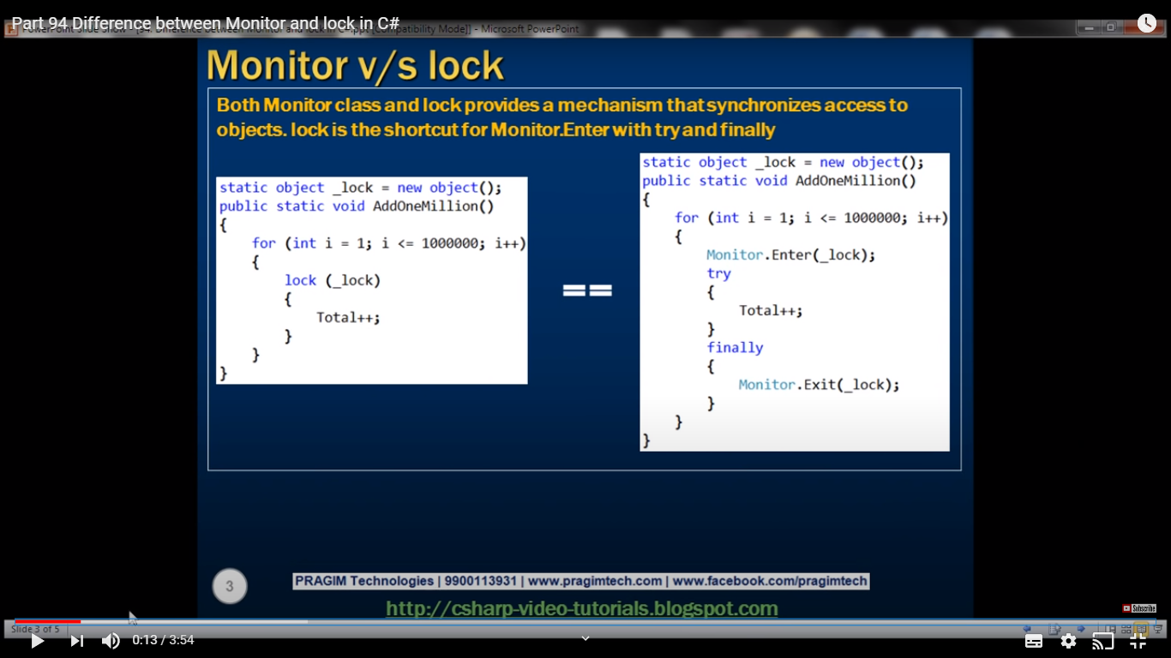

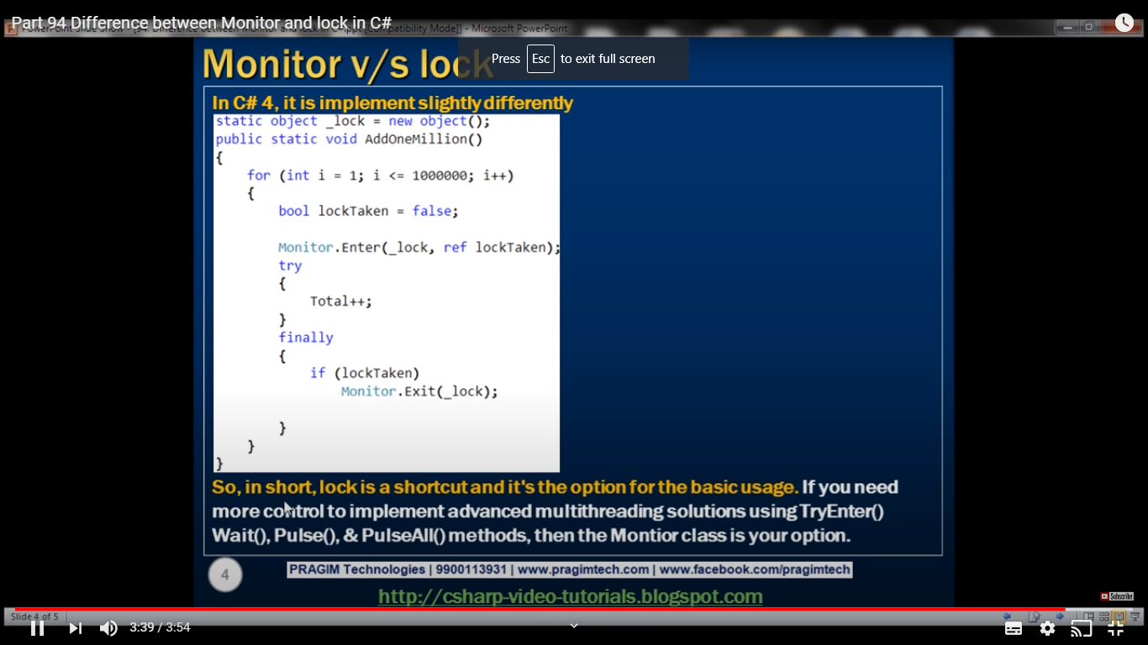

Attached property

-------------

post vs put

[FromUrl] and [FromBody]

== vs ===

5. Diff. b/w webforms and react js

|  |
| --- |
| 1. What is delegates |
| 2. What are inbuilt delegates -Func, Action, Predicate  ­­ |
| 3. What is sync (lock & Monitor concept) |
| 4. diff b/w abstract and abstraction |
| 5. Diff b/w abstract and interface |
| 6. Design pattern  Diff. b/w Tasks & thread    Implementing of the asynchronous functionality is very easy compare with thread    What is delegates  What is threadpool  How can you will avoid deadlock    Diff b/w lamda expression & anonymous  Diff b/w singletol vs static    Which OMR tool you used?  Entity framework  Diff. b/w monitor & lock  anonymous methods in #  Async & await in c#  https://www.youtube.com/watch?v=4trl43Ycksg&list=PLAC325451207E3105&index=98    Thread & process    multi threading & multi tasking  https://www.youtube.com/watch?v=No7QqSc5cl8  Linq system  Message queue  why inheritance use in interface  in API where we will use  where multi tasking we will use  diff b/w dispose & finalize  diff b/w events and delegates |

basic concept: 4 types

boxing/unboxing

overloandin/overriding

cahching

types of caching

how can prevent caching in particular page

What is the output of below program

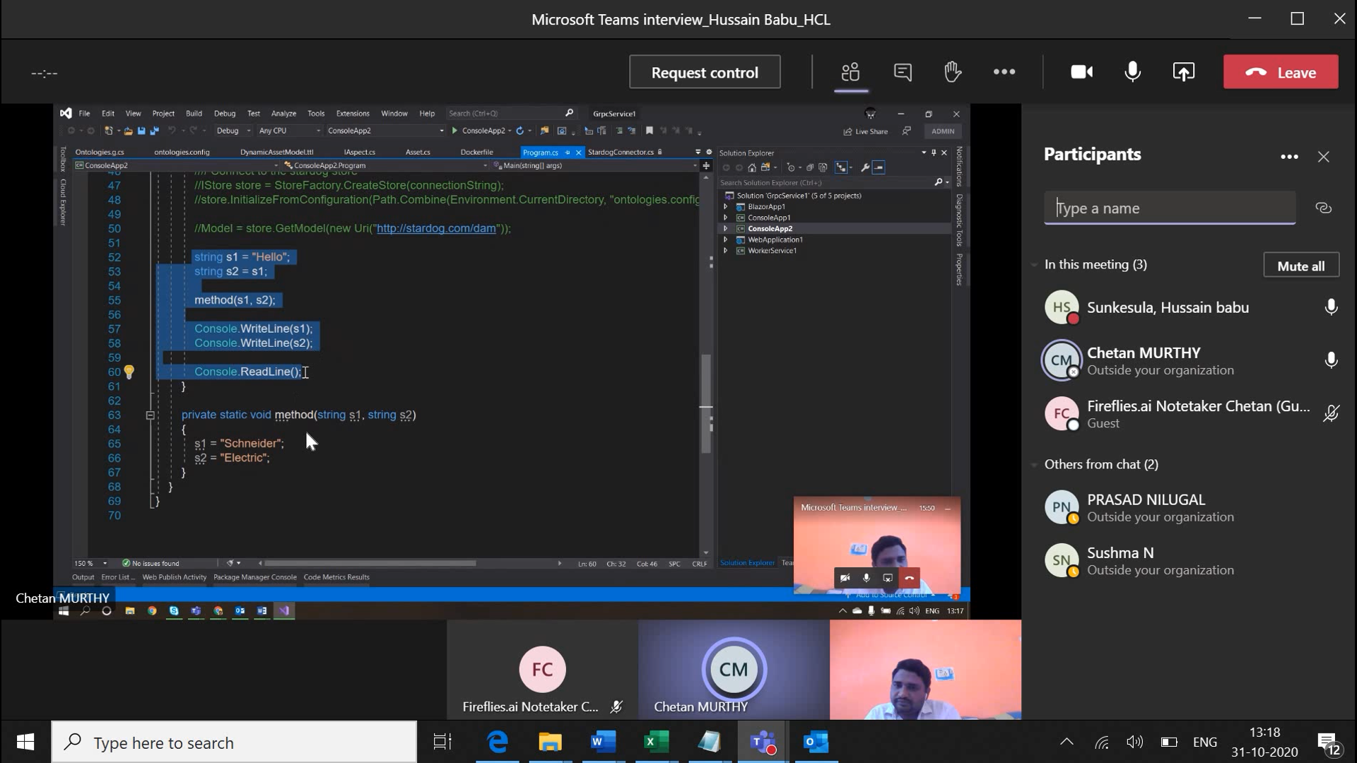

## Sql Server:

How to improve application performance, when db size increasing?

|  |
| --- |
| what is free table  <https://www.youtube.com/watch?v=hUOwCf61xXo> |
| diff b/w cluster & Non cluster |
| diff b/w function & SP |
| diff b/w primary & unique key |
| Write sql statement to find duplicate rows from table |
| Types of functions |
| how many types of joins?  cluster index & Non culster index  what are the views? Why we needs to use it? How it is different from tables?  What is Right outer join?  6. diff b/w rank & dense rank    7. What is CTE (Common table expression)  sql injection  prepared statement  Display month names based on number  Select DateName( month , DateAdd( month , @MonthNumber , -1 ) )  8. what is the use of Views?  How to delete duplicate rows from table.  DELETE FROM [SampleDB].[dbo].[Employee]  WHERE ID NOT IN  (  SELECT MAX(ID) AS MaxRecordID  FROM [SampleDB].[dbo].[Employee]  GROUP BY [FirstName],  [LastName],  [Country]  );  9. What are the functions?  How can you create optional parameter in stored procedure?    10. Write sql stmt to display top 3 salary without duplicate - **Use denseRank**  13. What is the solution you will provide to display million of records from db?  What is CTE? |

## WPF:

Wpf Orchitecture:

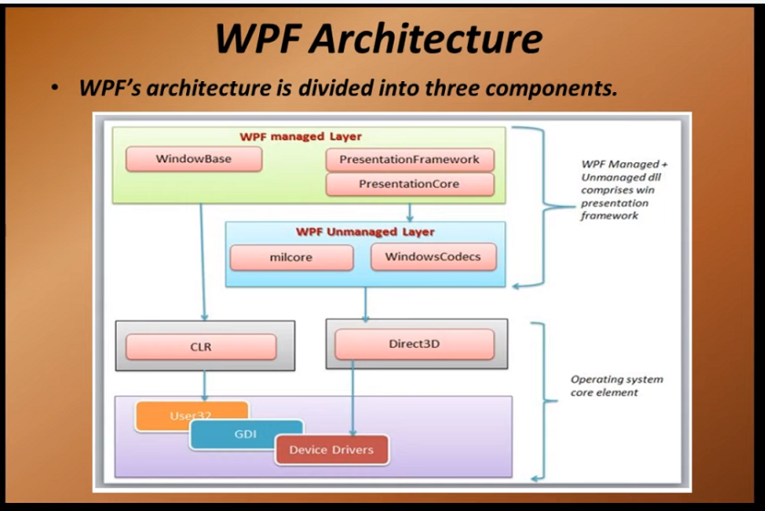

|  |
| --- |
| 1. what is static resource & Dynamic resource |
| 2. What is two way data binding |
| 3. What is Tunnel & bubble |
| 4. Diff. b/w MVVM & MVC |
| 5. Diff. b/ |

1. what is update source trigger?

2. what is INotifyPropertyChanged?

3. How can you will do binding in Password control box

4. Diff types of templates available?

5. Diff b/w item template and data template?

6. ICommand

14. Explain about multi tasking give the example **- Progress bar - Async, Task, wait**

Attached property

15. What is predicate?

## ASP.Net MVC

Why we have to go for MVC instead of web forms?

What is page life cycle in MVC?

What is ECMA script?

What is Razor engine?

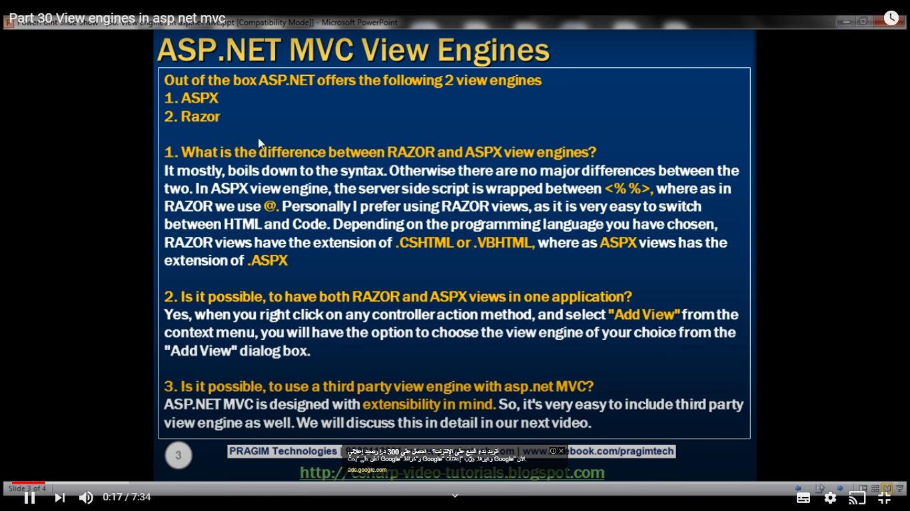

What is razor view engine

What is razor view syntax?

It helps to display c# variable value to html it will helpful. “@” symbol helpful for razor view

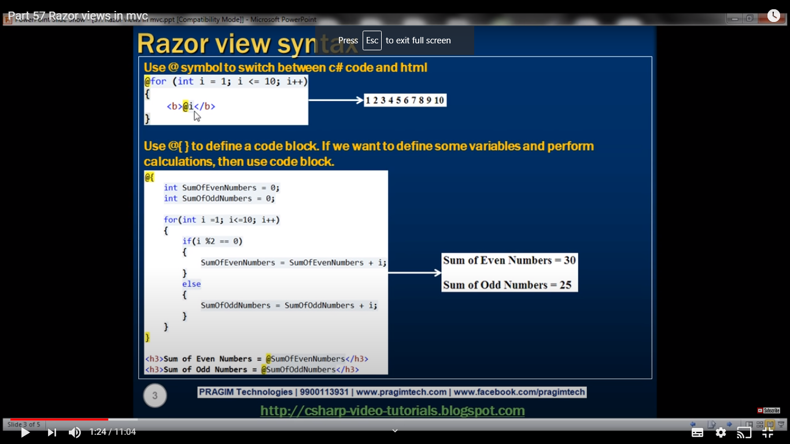

What are filters

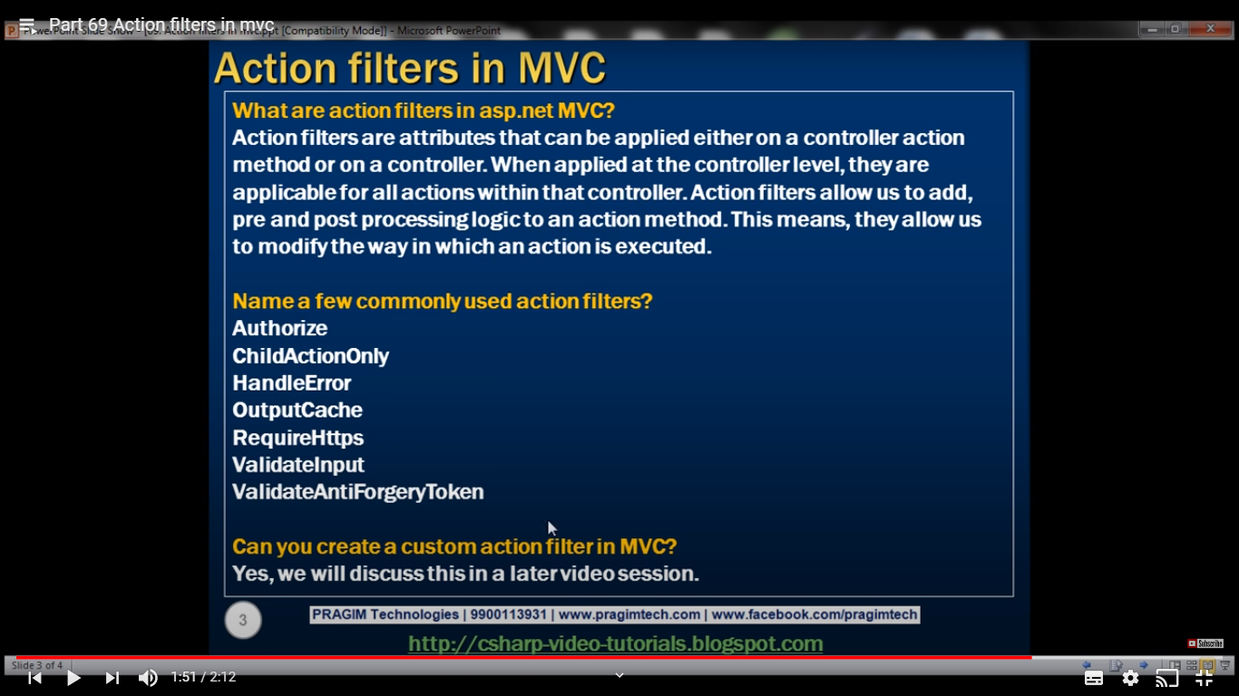

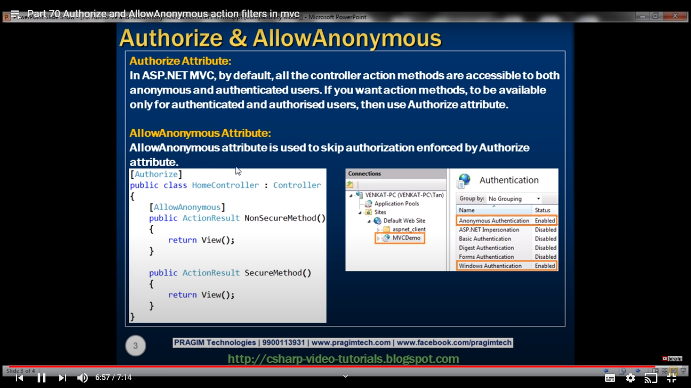

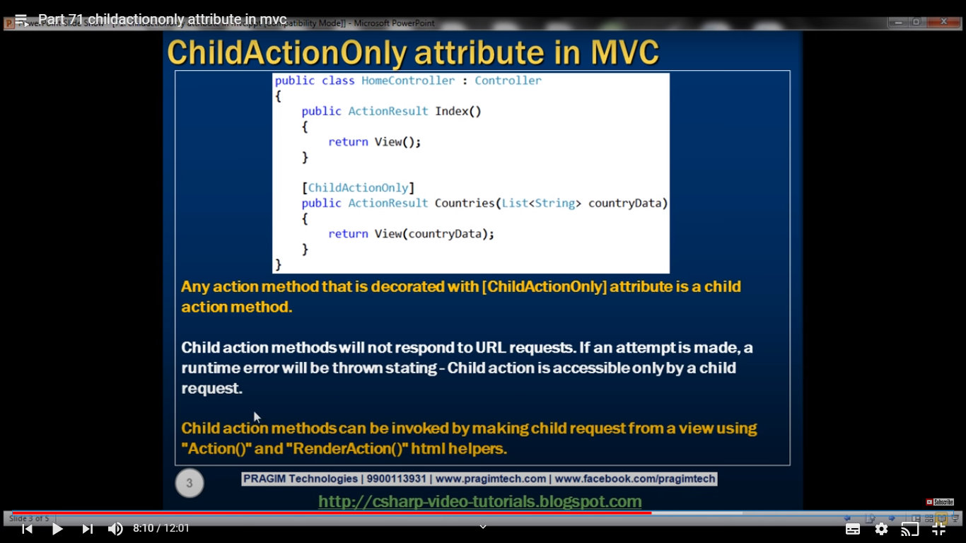

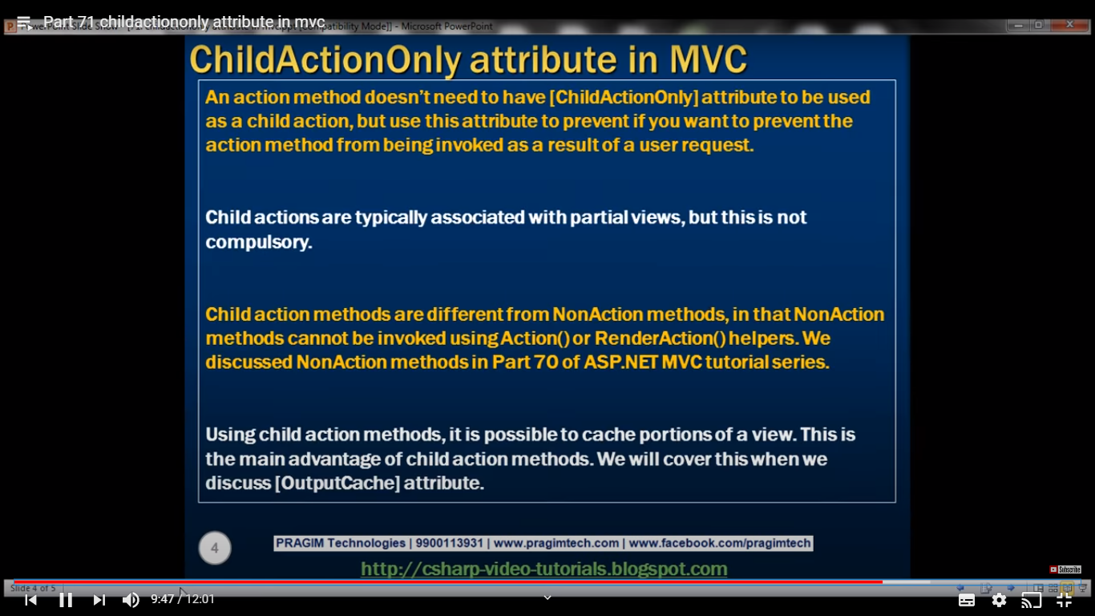

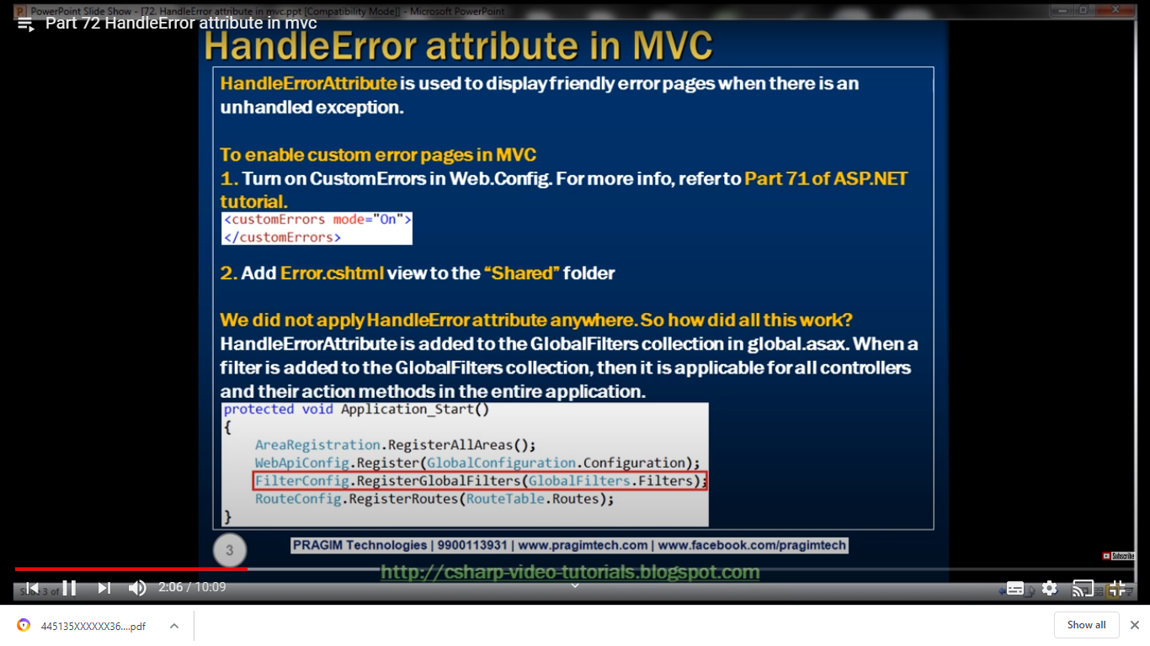

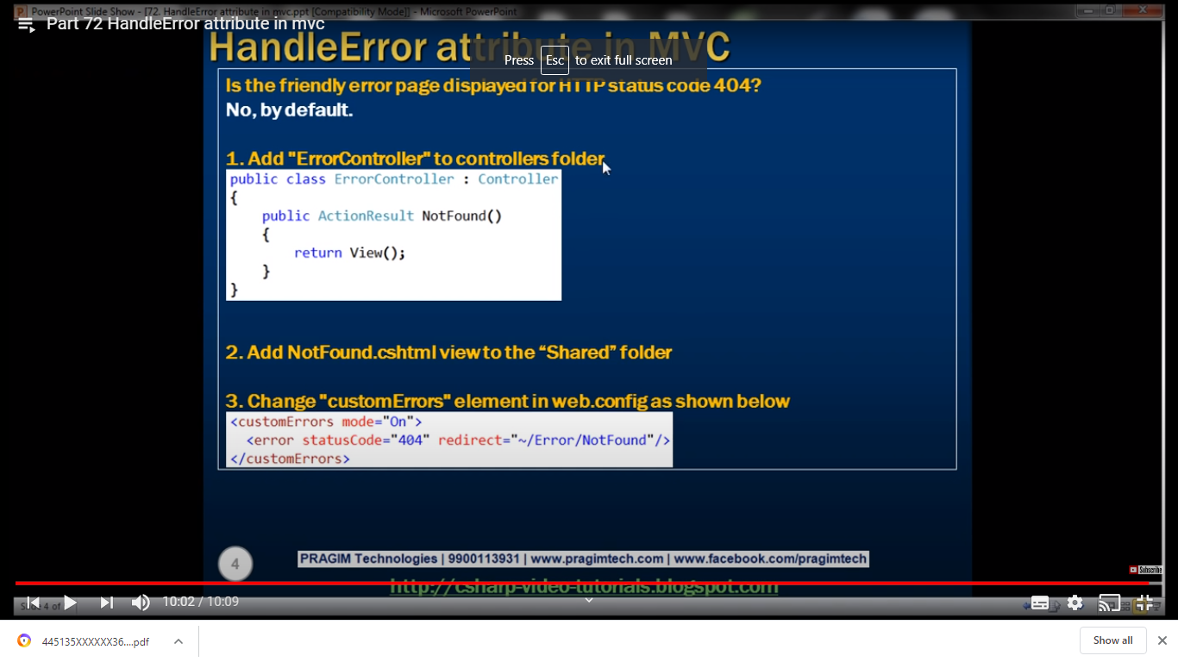

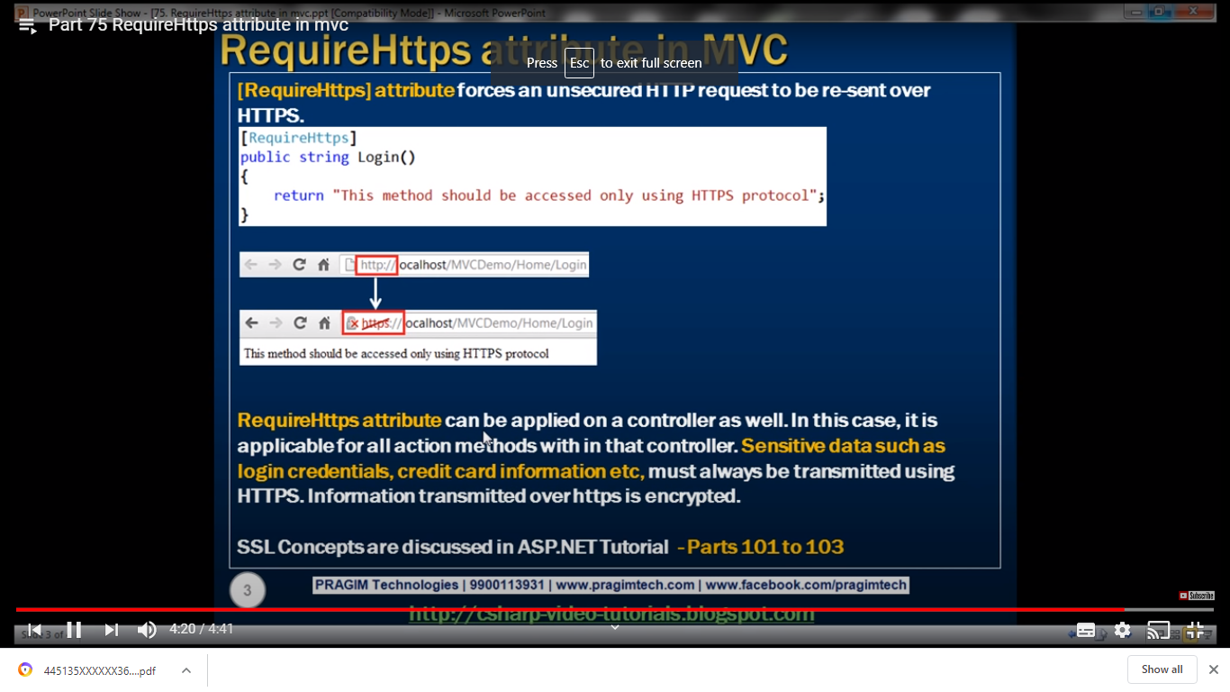

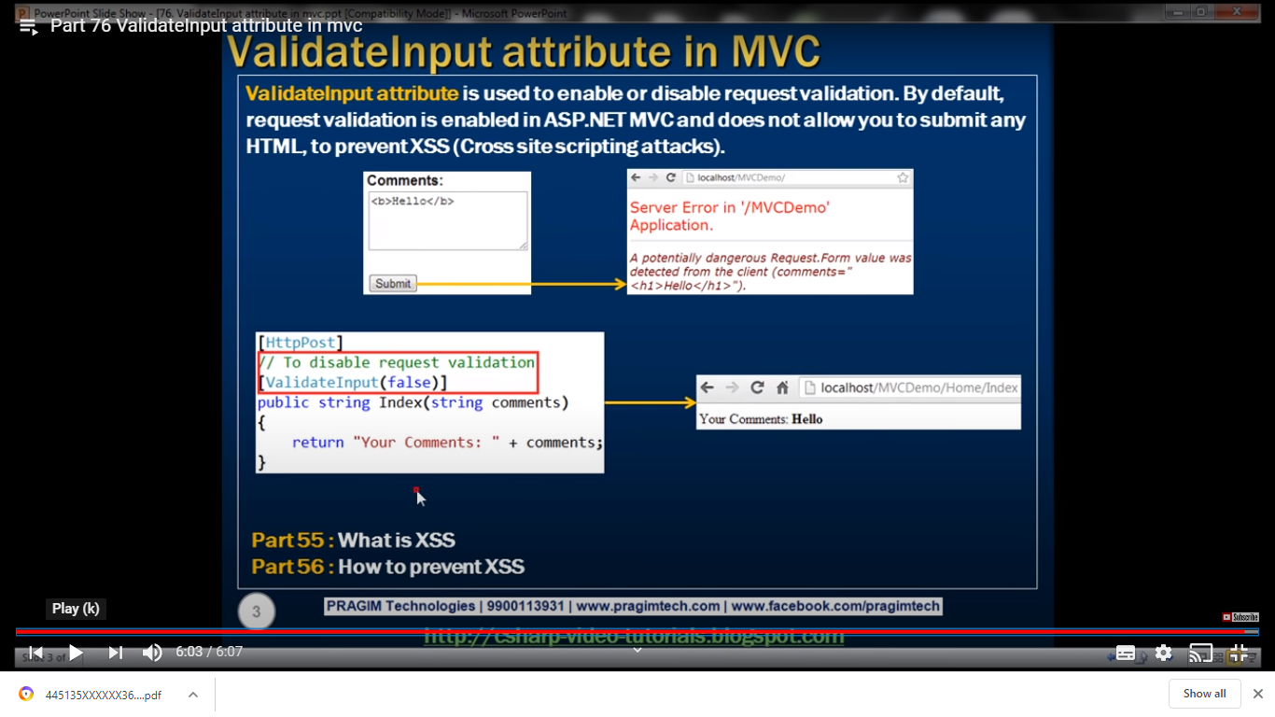

What is Html helpers? What are extension methods?

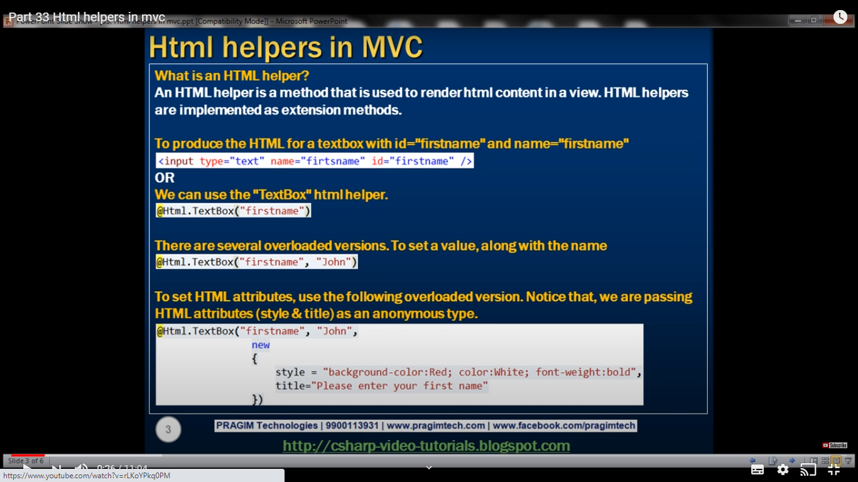

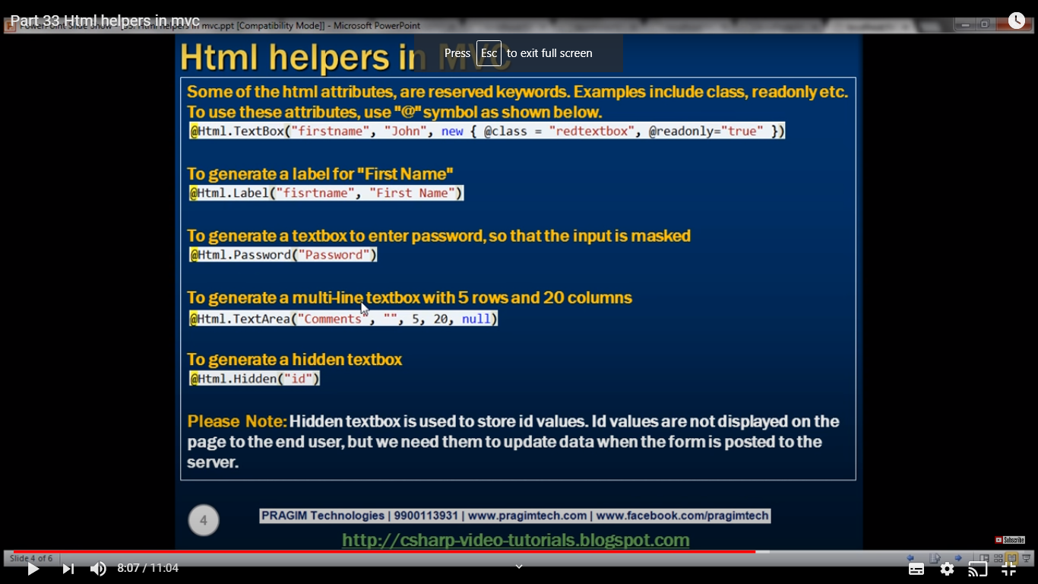

Why we have to use html helpers instead of html tags?

<https://www.youtube.com/watch?v=MFLJkFs5UW4>

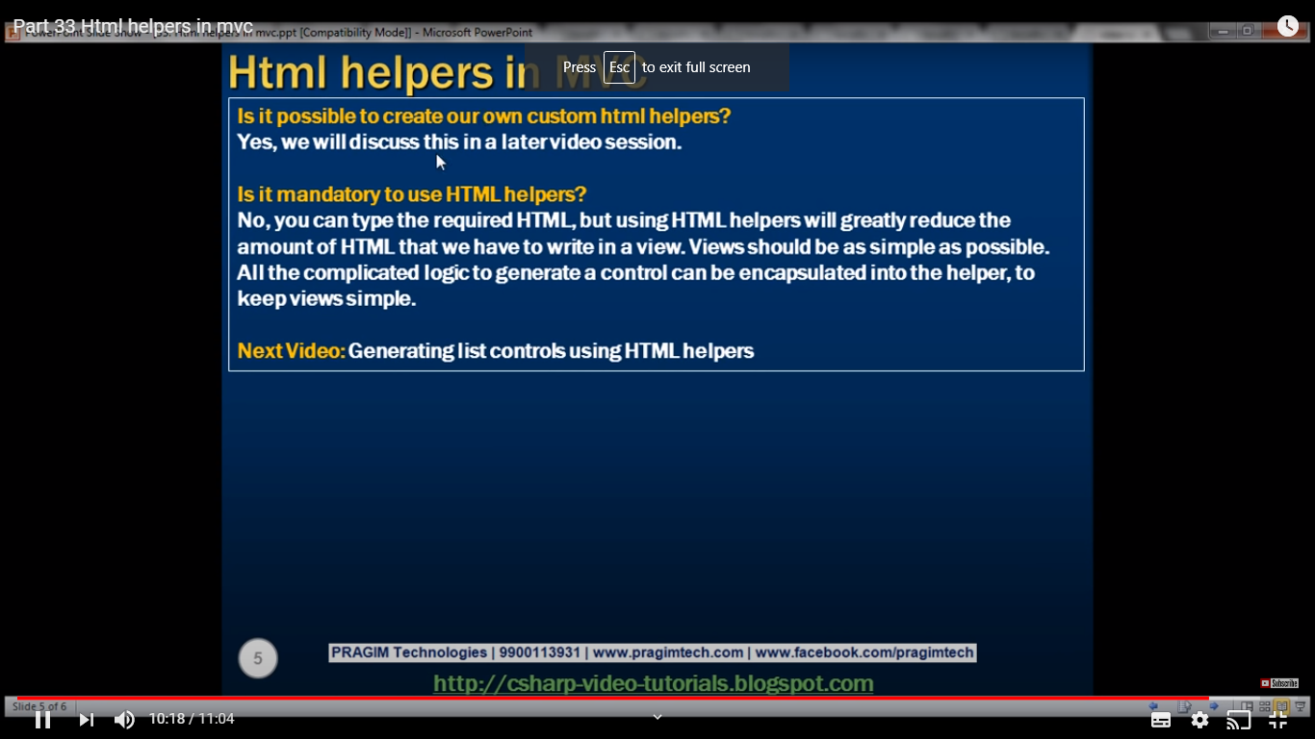

What are the different types of sessions?

Partial views in MVC?

What is Razor view?

How can you implement authentication in mvc?

Closure() in java script?

Asp.net routing

<https://www.youtube.com/watch?v=duQ1Pvr-oW0>

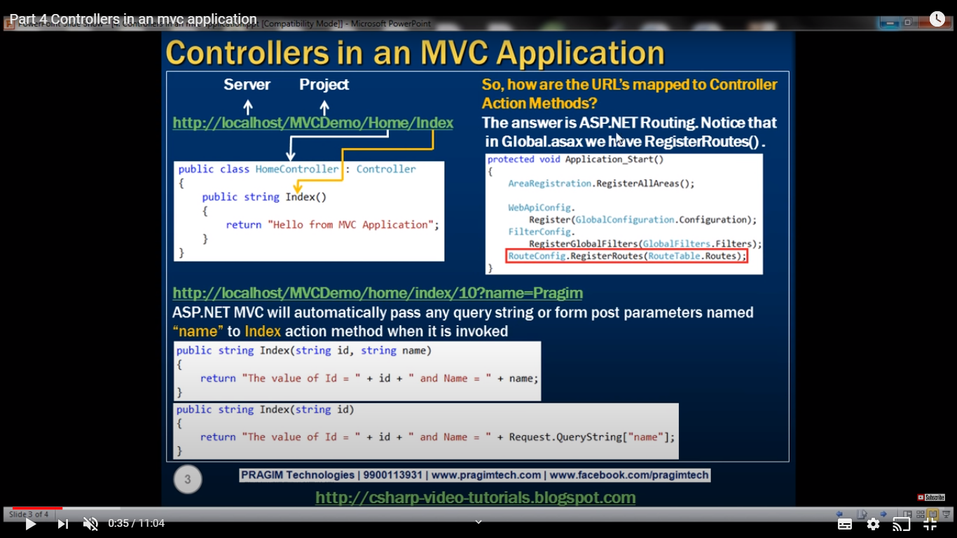

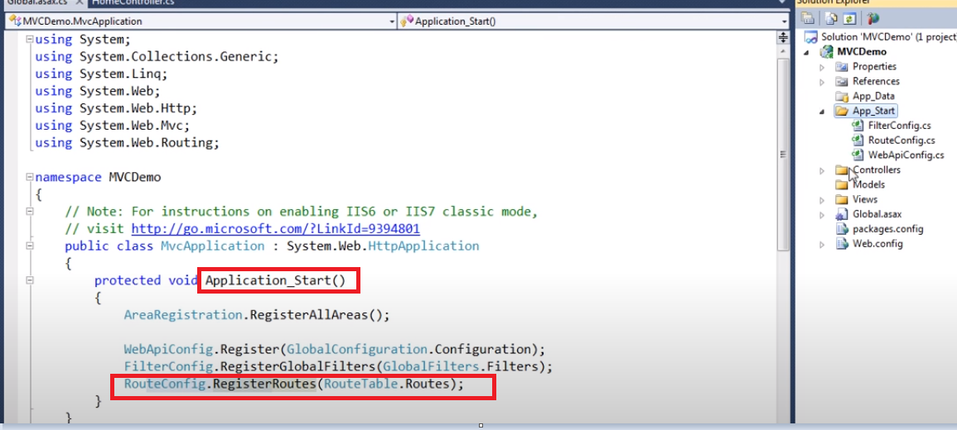

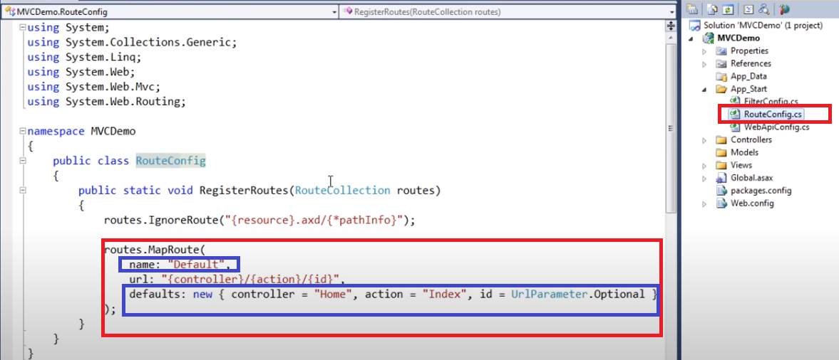

**Views: Viewbag**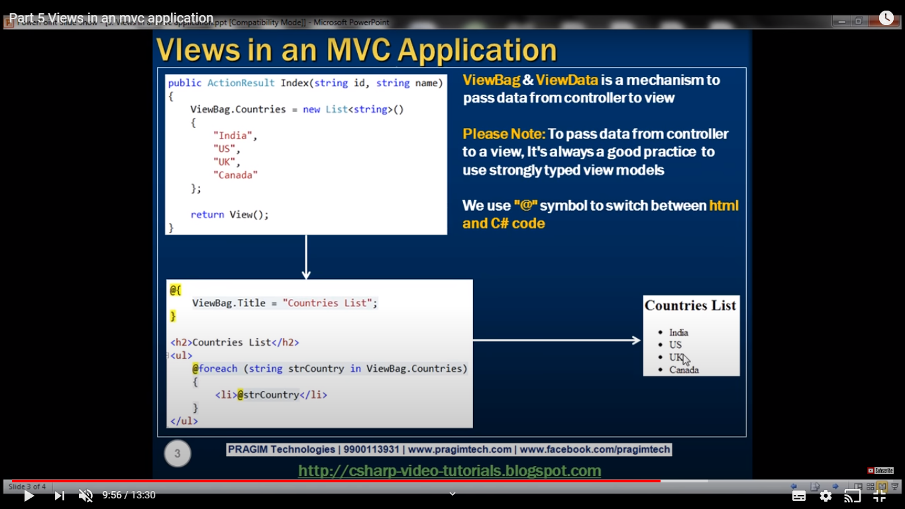

Diff b/w ViewData and ViewBag

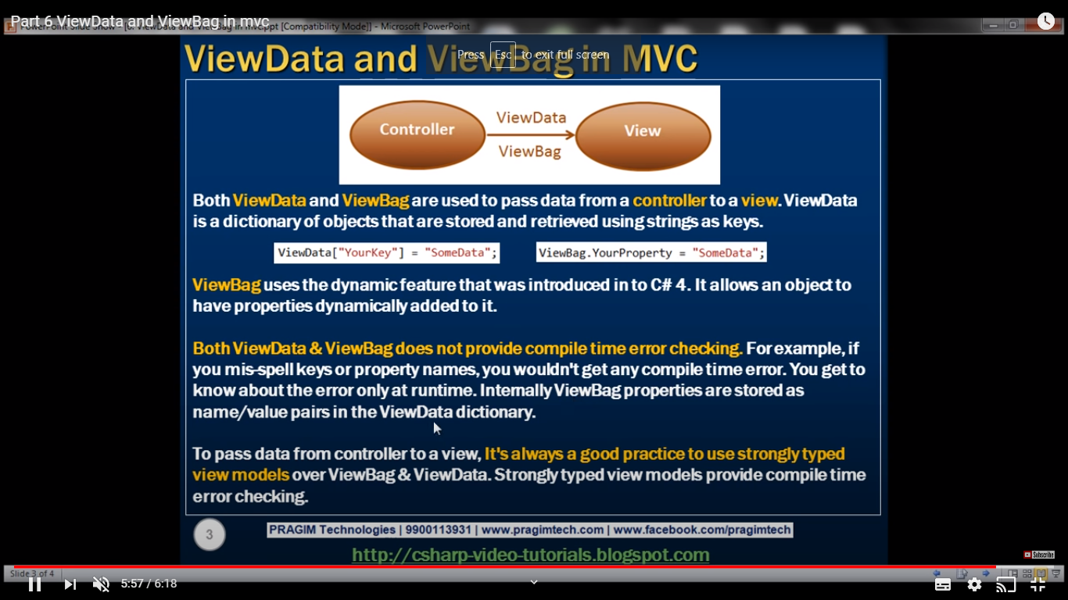

**Action selectors:**

* ActionName:

It helps to create alias name for the method. Eg. ActionName

* AcceptVerb Selectors

